Self-Inflicted Gonzo
On Attempted Resurrection in a Safe-for-Work World

The Wish
I want Hunter S. Thompson to walk through the door right now, LL Bean patchwork barn coat draped over himself, typewriter under one arm, whiskey bottle in the other hand, eyes wide with that particular combination of terror and amusement that made him the only journalist who could look directly at American madness without flinching.
Not because I miss his politics or his lifestyle or his conclusions about anything in particular. I want him here because discourse has become a pantomime, and he was the last person who knew how to break character in the middle of the performance.
The fantasy runs like this: Thompson arrives, surveys the landscape of 2025, and immediately recognizes the terminal symptoms. Not the obvious ones that everyone’s already catalogued — the polarization, the platforms, the algorithmic acceleration of human stupidity — but the deeper systemic failure. The way serious people have learned to speak about serious problems in voices so measured, so professionally concerned, so structurally unable to register the full scope of what’s happening that their very seriousness becomes another layer of the problem. He would see through the therapeutic language that’s colonized political discourse, where every crisis gets reframed as a mental health issue or a failure of individual resilience. He would recognize the particular form of cowardice that hides behind calls for nuance and balance when the building is on fire.
But Thompson isn’t coming through any door.
He’s been dead for twenty years. The wish itself reveals what’s missing from the current moment: someone willing to risk being wrong, excessive, inappropriate, offensive to the very people who need to hear what they don’t want to hear. I’m stuck with the admission that I need a partner who can’t arrive, craving a form of discourse that died with its last practitioner.

The Recognition
You know the feeling. You’re scrolling through another day of managed outrage, algorithmic fury, and professional concern, and something inside you starts screaming for an adult to enter the room.
Not any adult. Someone who can look at the systematic derangement and call it what it is without immediately retreating into therapeutic language or career management.
What you get instead is discourse optimized for safety, for professional advancement, for algorithmic distribution. Even the angriest voices modulate themselves for maximum shareability. They hit the right notes of moral outrage without crossing lines that might actually cost them something. The platforms reward intensity but punish specificity. They encourage performance but discourage risk. You watch political commentary that traffics in controlled fury, providing the emotional satisfaction of resistance without any genuine danger. You see investigative journalists wrapping substantive findings in professional objectivity, as if revealing systematic corruption were a matter of presenting balanced perspectives rather than documenting organized crime.
They uncover evidence of widespread fraud and present it with the emotional register appropriate for a quarterly earnings report.
This isn’t individual cowardice. This is structural capture. You’re witnessing the economic incentives that support public discourse rewarding incremental critique over systemic challenge. You’re seeing professional networks that depend on maintaining relationships that would be jeopardized by genuine confrontation. You’re watching platforms with built in mechanisms that suppress anything creating actual disruption rather than mere controversy.
You start to understand that the actual centers of power have learned to metabolize dissent as content. They fund the think tanks producing the criticism. They sponsor the conferences where critics gather. They employ former radicals as consultants.
The system has become so sophisticated at appropriation that genuine opposition requires abandoning the very platforms that make opposition visible.
And you’re complicit. Every click, every share, every moment of engagement feeds the machine you claim to oppose. You tell yourself you’re staying informed, but really you’re just staying entertained by your own outrage, consuming critique like any other product, building a personal brand around your sophisticated disappointment with how things work.

The Trap
The writer sits with the recognition that wanting Thompson reveals the absence of exactly what’s needed to fill the absence.
One cannot simply decide to become the kind of writer who operates without safety nets, who risks everything on the accuracy of perception, who treats discourse as warfare rather than conversation. The fantasy of becoming Thompson exposes its own impossibility. His approach emerged from a specific historical moment when institutional credibility was collapsing but hadn’t yet been replaced by managed skepticism. He could position himself as an outsider because there were still insides to be outside of.
Now the outsiders have been professionalized.
The rebels have brand managers. The revolutionaries have book deals. The entire apparatus of dissent has been incorporated into the entertainment industry, where authentic rage gets processed into consumable content and genuine insight gets repackaged as lifestyle advice. Thompson’s effectiveness came from his genuine inability to adapt to conventional social expectations, his constitutional incapacity for strategic thinking that would preserve career at the expense of insights.
He wasn’t performing rebellion.
He was genuinely unable to perform conformity.
The contemporary writer faces a different challenge: how to generate discourse that feels necessary without the psychological equipment that made Thompson’s approach possible. How to diagnose systematic horror while remaining functional enough to navigate the professional contexts that provide platforms for saying anything at all. The writer discovers that the most important observations are precisely the ones that can’t be said within professional contexts; that honesty about certain subjects requires institutional independence that takes years to develop and might never become sustainable; that pushing discourse beyond current boundaries might reveal those boundaries exist for reasons more substantial than convention or cowardice.

The Substitution
I keep writing anyway.
Not because I’ve solved the problem of wanting what can’t be willed into existence, but because the alternative feels worse. Continuing to operate within frameworks I recognize as insufficient. Waiting for someone else to risk saying what needs to be said.
The substitute won’t be Thompson and can’t be Thompson and shouldn’t try to be Thompson. But maybe the substitute can identify what made Thompson’s approach essential and figure out how those principles translate into contemporary conditions. Not the style or the substances or the specific targets, but the underlying commitment to treating cultural analysis as an emergency response rather than academic exercise.
This means accepting failure, embarrassment, professional suicide as acceptable outcomes.
It also means writing as if the stakes were genuinely high rather than managing reputation as if career advancement were the primary goal and prioritizing accuracy over acceptability, even when the distinction remains unclear. Consider what discourse actually needs: someone willing to diagnose terminal cultural symptoms without immediately proposing therapeutic interventions. Someone who can document systematic derangement without retreating into false comfort of historical precedent or false hope of incremental reform.
The current moment demands documentation of organized madness operating at every institutional level. Banks laundering money for cartels while foreclosing on teachers. Tech companies destabilizing democracies while selling digital wellness products. Pharmaceutical companies creating addiction epidemics while funding addiction treatment centers.
This isn’t conspiracy thinking. This is pattern recognition.
And I’m probably the wrong person to do it.

The Confession
I start to realize that this entire exercise might be elaborate procrastination. Wishing for Thompson becomes just another way of avoiding the work actually available to me. The fantasy of radical discourse might be preventing me from engaging with the less dramatic but more sustainable forms of cultural criticism in forms that don’t require personality disorders or professional suicide.
I catch myself romanticizing Thompson’s approach while ignoring its genuine costs:
the addiction, the paranoia, the isolation, the violence turned inward when the external targets became too diffuse to hit effectively.
Sometimes I wonder if the wish for his return says more about my own avoidance than about the inadequacy of contemporary discourse. Maybe the real problem isn’t that discourse has become too safe, but that I’ve become too comfortable with my own safety. Maybe the wish for someone else to take the risks reveals my own unwillingness to take them. Maybe my critique of professional discourse is just another form of professional discourse: generating content about the impossibility of generating content that matters.
I find myself writing sentences and then deleting them, not because they’re inaccurate, but because they feel performative. Honesty about my own motivations turns out to be harder than honesty about systematic corruption. The most important work might require admitting that I don’t know what the most important work actually is. The confession becomes recursive. Even admitting the confession might be a performance, self-awareness as another form of evasion, recognizing my own complicity without any meaningful change in behavior.

The Persistence
The wish for Thompson’s return doesn’t go away. He isn’t coming through any door, and there’s no institution left that could even authorize a substitute. What remains is the choice: keep wishing, or begin acting without adequate preparation. Something about this moment feels terminal in ways that demand responses I may not be capable of, while still demanding that someone attempt them anyway.
The banks are laundering money while the schools lose funding. The platforms amplify misinformation while pretending to fight it. The pharmaceutical companies manufacture addiction and profit from the cure. The spectacle has become so total that even criticism of the spectacle gets folded into the performance. The think pieces about media manipulation become media manipulation. The documentaries about propaganda become propaganda. The books about the attention economy become products in the attention economy.
And yet, something in me insists that this recognition matters, that seeing the system clearly might be the beginning of something other than more sophisticated participation in its operations. The persistence of the wish suggests that something in this cultural moment genuinely requires what Thompson provided: unmediated encounter with systematic absurdity, a willingness to risk everything on the accuracy of perception, a refusal to moderate insight for the sake of professional acceptability.

The Act
I’m writing this at 1:16 AM, which feels appropriately Thompson-like, though probably for the wrong reasons.
He wrote through the night because he was chemically incapable of sleep and because the night revealed truths that daylight made invisible. I’m writing through the night because I can’t figure out how to end this essay, because the conclusion keeps evading me, because the whole enterprise feels simultaneously necessary and ridiculous, and because I have insomnia again.
The door stays closed. Thompson isn’t coming. The work that needs to be done won’t be done by him or by anyone equipped with his particular combination of insight and self destruction.
It might not be done at all.
It might not need to be done. The urgency might be manufactured, another form of content generation, another way of avoiding the slower, less dramatic work of actually paying attention to what’s happening right in front of me. But I keep writing anyway. Not because I’ve solved the problem of wanting what can’t be willed into existence, but because the alternative feels worse.
Because someone has to be willing to get it wrong in spectacular fashion rather than continue getting it right in ways that change nothing.
Because the wish itself might be the only honest starting point available. The work begins badly, with inadequate equipment, insufficient authorization, no guarantee of success or relevance or even basic coherence. It begins with the admission that I need help I can’t get, partnership I can’t find, courage I don’t possess.
It begins with the recognition that beginning badly might be the only way to begin at all.
Thompson shot himself in his kitchen while his family was in the next room. Maybe he understood something about endings that I don’t. Maybe he knew when the work was finished, when the fight had moved beyond his capacity to engage it effectively. Maybe he just got tired.
I’m not tired yet. The door stays closed, but the keyboard keeps working. The wish persists, not as fantasy but as an engine, driving the work forward into whatever comes next, whatever form the substitute takes, whatever risk the act requires.
No one is coming to save us.
The work begins anyway.
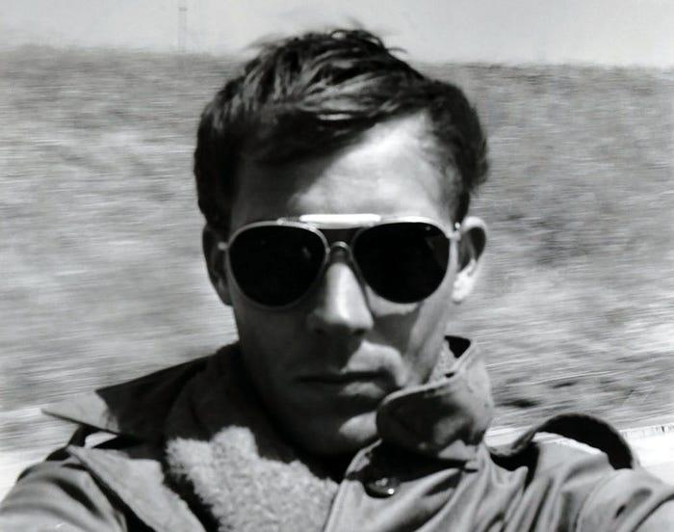
Hunter S. Thompson: Self-portrait, Tijuana, 1960s

